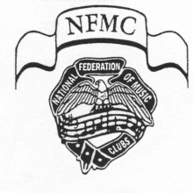
The Alabama Federation of Music Clubs
Junior Division
Return by July 31 if you wish to participate in the 2023-2024 Festival year.
Date _____________ New Club ________ Renewal _______
Name of Junior Club ____________________________________________
Counselor ____________________________________________________
Name of all Senior AFMC clubs of which you are a member. (We must hold current membership in a Senior club in order to Federate a Junior club. Examples would be B.M.T.A., Bush Hills Music Club or Gadsden Music Club).
____________________________________________________________________________________ Current year’s dues to a Sr. Club have been paid _____ Yes ____ No
Address _____________________________________________________
City ___________________ State ___ Zip ___________ Phone - CELL ______________________
E-mail address _____________________________________________ Number of Students __________
Dues Payable to AFMC and NFMC:
$33.00 per club of 16 students or less $1.55 per each additional student over 16
TOTAL ENCLOSED ______________
Make your check payable to Alabama Federation of Music Clubs: DISTRICT II
Mail along with this completed for to:
Cheryl Walls If you need help filling out this form,
1813 Forest Haven Ln please call Cheryl at 205-914-3566.
Vestavia Hills, AL 35216 E-mail: cwalls1813@aol.com
Junior Keynotes:
One copy of Junior Keynotes will be sent to the counselor without charge. Multiple copies may be ordered directly from NFMC.

Clubs with more than one teacher: Attach the name, senior club, address, and phone number for each teacher in the club.

